

Measuring What Matters in

Job Ready Assessment Blueprint

**Television Production**

Test Code: 3427 / Version: 01

**Copyright 2013**

*Television Production*

**General Assessment Information**

**Blueprint Contents**

General Assessment Information

Written Assessment Information

Specific Competencies Covered in the Test

Sample Written Items

Performance Assessment Information

Sample Performance Job

**Test Type:** The Television Production assessment is included in NOCTI’s Job Ready assessment battery. Job Ready assessments measure technical skills at the occupational level and include items which gauge factual and theoretical knowledge. Job Ready assessments typically offer both a written and performance component and can be used at the secondary and

post-secondary levels. Job Ready assessments can be delivered in an online or paper/pencil format.

**Revision Team:** The assessment content is based on input from secondary, post-secondary, and business/industry representatives from the states of Michigan, New York, New Jersey, Pennsylvania, and Virginia.

cip

Code

10.0202-Radio and Television Broadcasting Technology/Technician

Career Cluster 2-Arts, AV Technology and Communications

27-4012.00– Broadcast Technician

The Association for Career and Technical Education (ACTE), the leading professional organization for career and technical educators, commends all students who participate in career and technical education programs and choose to validate their educational attainment through rigorous technical assessments. In taking this assessment you demonstrate to your school, your parents and guardians, your future employers and yourself that you understand the concepts and knowledge needed to succeed in the workplace. Good Luck!

In the lower division baccalaureate/associate degree category, 3 semester hours in Television Production or Communications.

NOCTI Job Ready Assessment



Page 2 of 11

*Television Production*

**Written Assessment**

NOCTI written assessments consist of questions to measure an individual’s factual theoretical knowledge.

**Administration Time:** 3 hours

**Number of Questions:** 186

**Number of Sessions:** This assessment may be administered in one, two, or three sessions.

**Areas Covered**

**Safety**

**Pre-Production**

**Production**

**Post-Production**

**Ethics, Communications, and**

**General Field Knowledge**

**8%**

**16%**

**8% 49%**

**18%**

**9%**

NOCTI Job Ready Assessment

Page 3 of 11

*Television Production*

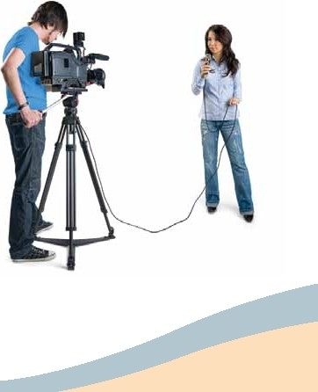

Specific *Competencies* and Skills f*ested* in this Assessment

**Safety**

·Demonstrate safe handling of lighting instruments

·Apply fundamentals of ladder safety

·Demonstrate knowledge of fire safety principles

·Identify appropriate personalsafety principles

**Pre-Production**

·Define target audience,including demographics and ratings

·Create or prepare production schedule/timeline

·Identify various budget/financial issues

·Demonstrate knowledge of concept development

·Demonstrate knowledge of various script formats,including storyboarding

·Determine technicalrequirements and site survey/location scout

·Identify and describe various communication delivery methods

·Select crew and cast talent for appropriate production requirements

·Design and construct sets and lighting

(Continue.::! on the following *page)*

NOCTI Job Ready Assessment Page4 of 11

*Television Production*



Specific *Competencies* and Skills (continued)

**Production**

·Prepare graphics appropriate to production

·Execute various lighting designs

·Direct and produce a studio production

·Direct and produce a remote production

·Collect, set up,and maintain props,set dressings,and scenery

·Select appropriate music for production

·Perform on-camera production skills

·Identify and select appropriate make-up and costumes

·Identify parts of cameras,accessories,and camera support systems

·Perform camera movements

·Properly adjust cameras (i.e.,exposure,white balance)

·Demonstrate appropriate lens operation and framing

·Identify various live transmission methods

·Identify and maintain various recording and file management systems

·Determine microphone selection and application

·Identify and operate various audio devices in a recording environment



\

'

(Continued on the following *page)*

NOCTI Job Ready Assessment Page 5 of 11

*Television Production*



Specific Competencies and Skills (continued)

**Post-Production**

·Identify and describe proper editing techniques

• Demonstrate editing aesthetics (i.e.,transitions,pacing of shots,background

music selection)

·Identify and manage various file formats

·Import,capture,and export media appropriately

·Identify and describe digital video signals

·Describe procedures for preparing production for distribution

·Describe and apply motion graphics and video compositing (including CG,

chromakey)

·Evaluate the finished product with the client/audience

·Identify and describe essential computer hardware for editing

**Ethics,Communications, and General Field Knowledge**

·Identify and define various career paths in the video production/broadcasting

field

·Exhibit knowledge of copyrights,contracts,ethics,and industry legalities

·Cooperate professionally with clients,coworkers and supervisors

• Demonstrate knowledge of the business aspects of the video/broadcasting field

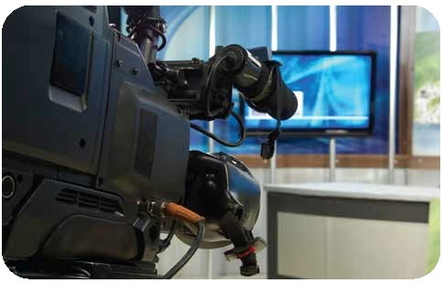

NOCTI Job Ready Assessment Page6 of 11

*Television Production*

**Sample Questions**

**In the traditional two-column script format, what information is placed in the left column?**

A. music

B. sound effects

C. camera directions

D. actor's dialog

**Items on a set such as pictures, lamps, and plants are called**

A. platform pieces

B. set aesthetics

C. background pieces

D. set dressings

**When adjusting lights on a subject, a worker should**

A. wear sunglasses because lights are bright

B. wear solid colors

C. never wear pinstripes or clothes with busy patterns

D. wear gloves because lights are very hot

**In digital media, sound and light are translated into**

A. binary code

B. time code

C. vector

D. codec

**Zebra stripes**

A. indicate overexposure

B. produce unique effects in the program

C. designate battery power on a camcorder

D. show that the camcorder is recording

**(Continued on the following page)**

NOCTI Job Ready Assessment

Page 7 of 11

*Television Production*

**Sample Questions (continued)**

**To avoid a jump cut, use a**

A. split

B. key

C. cutaway

D. lower third super

**When setting up an editing station, the choice of proper ergonomics should also minimize**

A. static discharge

B. carpal tunnel syndrome

C. electrical hazards

D. ocular degeneration

**What is the best way to design studio lighting?**

A. Put gels in all the lighting instruments.

B. Draw a light plot. C. Draw a floor grid.

D. Adjust the background until the set is well lit.

**A common entry-level position in television production is a/an**

A. production assistant

B. audio control operator

C. editor

D. CG operator

**The purpose of a focus group is to**

A. keep several images in focus on the screen

B. execute rack focus

C. manipulate f-stop on zoom lenses

D. test audience views on a program

NOCTI Job Ready Assessment

Page 8 of 11

*Television Production*

**Performance Assessment**

NOCTI performance assessments allow individuals to demonstrate their acquired skills by

completing actual jobs using the tools, materials, machines, and equipment related to

the technical area.

**Administration Time:** 3 hours

**Number of Jobs:** 3

**Areas Covered:**

**31% Create and Script Video**

Participant will create a script for a 60-second video profile of another person, adhere to the script format

and video instructions. The video must include technical descriptions of shots, music, and titles.

**28% 31%**

**41%**

**41% Shot Composition**

Participant will perform all shots with high quality and correct camera movements.

**28% Edit Shots with the Interview**

Participant will edit the video from first job following all instructions and ensure that a

leader is included.

NOCTI Job Ready Assessment



Page 9 of 11

*Television Production*



Sample Job

( **Create and Script a Video** )

**Maximum Time:** 45 minutes

**Participant Activity:** The test participant will create a script for a 60-second video profile of another individual.

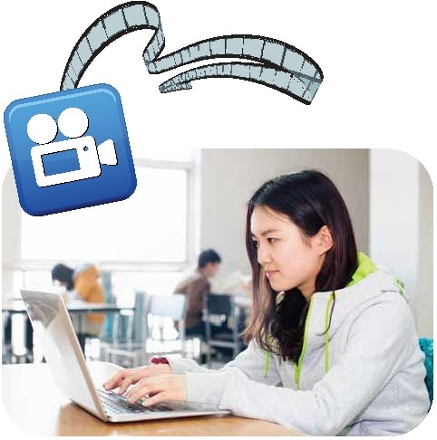

NOCTI Job Ready Assessment Page 10 of 11

*Television Production*



***Notes***

NOCTI Job Ready Assessment Page **11 of 11**

